Iron addition as a measure to restore water quality: implications for macrophyte growth

Immers, A. K., Mels-Vendrig, K., Ibelings, B. W., Van Donk, E., Ter Heerdt, G.N. J., Geurts, J. J. M. & Bakker, E. S.

SUMMARY

1. Eutrophication of shallow lakes in North-West Europe has resulted in (toxic) algal blooms, turbid water, biodiversity loss, and a decline in submerged macrophytes. Even though external inputs of phosphorus are declining, internal loading of P from the sediment seems to delay the recovery of these aquatic ecosystems. Iron is a useful chemical binding agent to combat internal phosphorus loading in shallow lakes when added to the water column and/or sediment, as shown in mesocosms. However, at the whole-lake scale iron addition may be most feasible in the surface water, whereas the effects on aquatic macrophytes are not yet known and iron may be potentially toxic.
2. In this study we experimentally tested the potential toxicity of Fe in the form of iron(III)chloride (FeCl₃) on two different aquatic macrophytes, the facultative rooting species Elodea nuttallii (Planch.) St. John and the rooting species Potamogeton pectinatus L. Iron was dosed in two different concentrations in either the surface water and in both surface water and sediment.
3. The degree of iron tolerance seemed to be species specific. Elodea nuttallii growth was not affected, whereas P. pectinatus growth significantly decreased with increasing iron concentrations. Nonetheless, P. pectinatus biomass increased in all treatments relative to starting conditions. The place of iron addition, either in the water column or in both in the water column and in the sediment, did not affect biomass or biomass allocation in both species.
4. During the experiment, a large number of propagules sprouted from the sediment, which was not influenced by increasing iron concentrations. Interestingly, the species that sprouted from the sediment (Nitella mucronata, Chara virgata, and Chara globularis) are currently rare in the lake and have a high conservation value.
5. The addition of 25 or 50 g Fe m⁻² in the surface water or combined in the surface water and sediment can negatively affect macrophyte growth, but was not lethal for macrophytes and their propagules in the sediment during the 3 months of our study. Therefore, we conclude, that adding iron(III)chloride in these amounts to the surface water does not prohibit macrophyte return and can potentially be a useful method to restore eutrophicated shallow lakes.

Introduction

High nutrient loading from agricultural runoff and wastewater discharge during the second half of the 20th century has led to eutrophication of many shallow lakes in North-West Europe. This excess input of generally growth limiting phosphorus (P) has resulted in (toxic) algal blooms and consequently turbid water, biodiversity loss, and a decline in submerged macrophytes (Tilman et al. 2001; Smith 2003; Søndergaard et al. 2007; Hickey & Gibbs 2009).
Submerged macrophytes play a key role in the functioning of shallow water ecosystems by serving as a nutrient sink, a habitat for fauna and a stabilizer of bottom sediment through which they stabilize the clear water state of these ecosystems (Scheffer et al. 1993; Jeppesen et al. 1998; Gulati & Van Donk, 2002). However, after eutrophication a strong reduction in P loading of a lake is required to restore a lake to this self-stabilizing clear water state (Cooke et al. 1993; Jaeger 1994; Jeppesen et al. 2005). Moreover, internal loading of P from the sediment seems to delay the recovery of these aquatic ecosystems (Cooke et al. 1993; Jeppesen et al. 1998; Søndergaard et al. 2003).
Under natural conditions many of these systems would not suffer from high internal P loading, as upwelling iron rich groundwater naturally binds to phosphorus (in the form of phosphate) in the sediment. However, input of iron rich groundwater has often decreased due to regional desiccation which consequently has led to a decrease in the amount of iron in the top layer of the sediment (Smolders & Roelofs, 1996; Van der Welle et al. 2007b). Hence, one way to cope with internal P loading is by improving the P binding capacity of the lake sediment by adding iron (Fe) or other chemical P binding agents such as aluminum (Al) or calcium (Ca) to the sediment (Cooke et al. 1993; Burley et al. 2001; Smolders et al. 2006). These chemical binding agents, if added on a regular basis, will not only precipitate with the available phosphate (PO₄) in the sediment, but can also provide long-term control of internal P loading from the sediment (Boers et al. 1992; Cooke et al. 1993; Boers et al. 1994; Smolders et al. 2006).
Various mesocosm experiments have shown that the addition of Fe to the sediment indeed results in lower total phosphorus (TP) concentration in the water column (Boers et al. 1992; Cooke et al. 1993; Smolders et al. 1995; Smolders et al. 2001; Van der Welle et al. 2006; Van der Welle et al. 2007b). High Fe concentrations in the sediment, however, can have deleterious effects to its surrounding environment (Kamal et al. 2004). Recent experiments have shown that growth of plants can be inhibited by high iron concentrations in the sediment for instance by the formation of necrotic leaf spots and iron plaques on roots (Lucassen et al. 2000; Van der Welle et al. 2006). Moreover, the addition of iron to the sediment may be possible in mesocosms, but is a challenge for a whole lake. Adding iron to the surface water may be more feasible in case of restoration of a whole lake. However, the effects of adding iron to the surface water on aquatic macrophytes are not yet known.
In this study we experimentally tested the potential toxicity of Fe in the form of iron(III)chloride (FeCl₃) in the surface water on two different aquatic macrophytes, the facultative rooting species Elodea nuttallii (Planch.) St. John and the rooting species Potamogeton pectinatus L. The experiment is based upon the situation of lake Terra Nova, the Netherlands, in which this method of FeCl₃ addition to the surface water is now being applied. Furthermore, to simulate a condition in which bioturbation and wind-induced mixing have resulted in an accumulation of FeCl₃ in the sediment, we added a treatment in which we, prior to the start of the experiment, mixed half of the total amount of FeCl₃ in the sediment. To study the effect of iron toxicity we focused on changes in macrophyte growth, biomass allocation, and nutrient composition.

Methods

Experimental set-up
In February 2010, 90 polyethylene tanks (w x l x h = 0,19 x 0,19 x 0,29 m) were set up at the NIOO-KNAW in Nieuwersluis. The tanks were placed in a temperature and light controlled culture room with a constant temperature of 18 °C and light intensity of 100 ± 5 µEinsteins m⁻² s⁻¹ in a 14:10 h light:dark cycle. Each tank was filled up with 2 L peat sediment, collected in Lake Terra Nova (52º 12’ 55.87” N, 5º 2’ 23.00” E). Before tanks were filled, 18 different treatments were allocated to the tanks, each with 5 replicates.
The effects of iron addition were tested with total additions of 25 g Fe m⁻² (low) and 50 g Fe m⁻² (high) in the form of FeCl₃. A control treatment was designed which would receive NaCl in equal molar amounts of chloride in the high iron treatments.
The sediment of tanks in which iron was offered to both the water column and sediment (i.e. mix treatments) was pre-mixed with half of the total amount of the designed FeCl₃ and NaCl. Subsequently, 7.3 L of filtrated (ME 24, Whatman, Brentford, UK) Terra Nova water was poured very carefully on the sediment. To enable pore water sampling, Rhizon soil moisture samplers (Eijkelkamp Agrisearch Equipment, Giesbeek, the Netherlands) attached to 50 mL vacuum syringes were inserted into the upper layer of the sediment. Three E. nuttallii shoots were planted in the sediment of each tank of treatments 1-6 (total FW per tank 0.77 ± 0.39 g), three P. pectinatus shoots were planted in the sediment of each tank of treatment 7-12 (total FW per tank 0.44 ± 0.18 g), and the tanks of treatments 13-18 were kept empty as control treatments. Macrophytes that sprouted from the sediment propagule bank during the experiment were counted, removed and determined to the species level.
Iron was added over 12 weeks on 36 addition days, which corresponds to the low and high iron addition respectively to 14 and 28 mg FeCl₃ per addition day. The mix treatments, in which half of the total FeCl₃ and NaCl dose was already mixed in the sediment, received only half of the aforementioned dose per addition day. Moreover, a low dose of 0.73 mg FeCl₃ was added once at day 1 to the NaCl treatments to bind the available P in the water column (Ter Heerdt & Hootsmans 2007) to exclude P limitation effects.

Sampling and analysis
At day 1, 13, 27, 41, 55, 69 and 83 of the experiment, 105 mL of surface and sediment pore water samples were taken from each tank for chemical analyses. Directly after the pore water had been collected, 50 mL was fixed in polyethylene bottles with 1 mL nitric acid (2 M) for Fe, Al, Ca and SO₄ analysis. Another 20 mL of pore water was stored in polyethylene bottles for Cl analysis. Surface water samples of the same volumes were filtrated over a 0.45 μm membrane filter (ME 25, Whatman, Brentford, UK) before storage in polyethylene bottles and fixation in nitric acid. Membrane filters that were used for the filtration of 20 mL surface water were dried for 24 hours at 60 °C and afterwards stored in 50 mL centrifuge tubes. Subsamples of 10 mL were taken from both surface and pore water and filtrated over Whatman GF/C filters. All samples were stored at -20 °C before analyses.
A 25 mL subsample from both surface and pore water was used to measure pH and alkalinity with a TIM840 titration manager (Radiometer Analytical, Copenhagen, Denmark). Alkalinity was determined by titrating with 0.01 M HCl down to pH 4.2. The 10 mL subsamples were used to colorimetrically determine PO₄, NH₄, NO₃, and TN (with which NO₂ was calculated) with a QuAAtro CFA flow analyser (Seal Analytical, Norderstedt, Germany). Dissolved Fe, Al, Ca, and S (calculated to SO₄) were measured using an inductively coupled plasma emission spectrophotometer (Liberty 2, Varian, Bergen op Zoom, the Netherlands) according to the Dutch NEN-EN-ISO 17294. The same method was used to measure precipitated Fe on the collected membrane filters, which were treated with 8 mL nitric acid (2 M) before analysis. Chloride was measured spectrofotometrically (Aquakem 250, Thermo Fisher Scientific, Waltham, MA, USA) with extinction at 480 nm.
At the end of the experiment, all aquatic macrophytes were harvested, separated in above- and belowground material, dried for 24 hours at 60 °C, and subsequently weighed to determine the total dry weight. Total dry weight at the start of the experiment was calculated with a conversion factor, which was acquired from the fresh and dry weight of several subsamples. A homogenised portion of dry macrophyte material was used to determine both C and N concentrations with a FLASH 2000 Organic Elemental Analyzer (Interscience, Breda, the Netherlands). Macrophyte P concentrations were acquired by incinerating homogenized dry material for 30 minutes at 500 °C, followed by digestion in H₂O₂ (Murphy & Riley 1962) before analysis with a QuAAtro CFA flow analyser.

Statistical analysis
Statistical analyses were carried out with SPSS 18.0 (SPSS, Chicago, IL, USA). Differences between treatments for chemical variables, plant biomass and plant nutrient composition were tested with a univariate ANOVA using Tukey’s post-hoc test. Prior to analysis, all data were tested for normality and homogeneity of variance, and if necessary, data were log 10 transformed. For data that had no normal distribution, even after transformation, a nonparametric Kruskall-Wallis test was used with Statistica 9.1 (StatSoft Inc., Tulsa, OK, USA) to analyze variances. P ≤ 0.05 was accepted for statistical significance.

Results

Macrophyte biomass response
Total macrophyte biomass (roots plus shoots) showed an increase over time in all treatments, yet iron addition induced a different response in the two macrophyte species (Table 1; Figure 2). Elodea nuttallii biomass did not differ between the different iron treatments. In contrast, iron concentrations had a negative effect (Table 1) on growth for Potamogeton pectinatus, which had a considerably lower biomass in the high iron treatment compared to the control treatment (Figure 2cfi). No effect on macrophyte growth was observed between adding iron to the water column or to both the water column and the sediment. Biomass allocation was not affected by either iron addition or place of addition, as macrophyte shoot:root ratio did not differ between treatments (Figure 2jkl).
During the experiment a large number of macrophyte species sprouted from the sediment. Most observed were Nitella mucronata (A.Braun) Miquel, Chara virgata Kützing, Chara globularis Thuillier and Nuphar lutea (L.) Sm. Iron effects on differences in abundance were not observed, however seedlings sprouted more often in empty tanks compared to tanks with E. nuttallii and P. pectinatus (ANOVA: F = 5.45, P < 0.01, data not shown). Noteworthy was the formation of red iron precipitates on macrophyte shoots and tank sides in several tanks receiving high iron additions and dense growth of periphyton in a number of control treatments.

Tissue nutrient concentrations
Following the water nutrient concentrations, the mean end P concentrations of both E. nuttallii and P. pectinatus (1.17 ± 0.06 and 1.29 ± 0.05 mg g dryweight⁻¹) showed a steep decrease compared to start concentrations (6.29 ± 0.32 and 6.17 ± 0.57 mg g dryweight⁻¹). N concentrations showed this trend as well with low mean end concentrations (10.40 ± 0.46 and 10.22 ± 0.31 mg g dryweight⁻¹) compared to start concentrations (45.79 ± 0.58 and 34.99 ± 1.87 mg g dryweight⁻¹). No differences in macrophyte nutrient concentrations were found between iron treatments (Table 1). The relative higher decrease in mean macrophyte P concentrations over time compared to N concentrations for both macrophyte species resulted in increased mean N:P ratios from 16.10 ± 0.63 and 12.54 ± 1.88 mol mol⁻¹ at the start of the experiment to 17.38 ± 1.42 and 17.66 ± 1.56 mol mol⁻¹ at the end of the experiment for respectively E. nuttallii and P. pectinatus (Figure 3). Tissue nutrient concentrations in above ground macrophyte material showed the same reaction to the different treatments as nutrient concentrations in below ground material.

Surface and pore water analysis
During the experiment, iron concentrations in both surface and pore water of the high iron treatments increased significantly to end concentrations of respectively 0.35 and 7.13 μmol L⁻¹ (Table 2). Precipitated iron, which was measured in the surface water, reached in the high iron treatment the highest mean concentration of 6.63 ± 2.10 μmol L⁻¹ (Table 2). In addition, precipitated iron was significantly higher in the treatments in which iron was only added to the surface water compared to mix treatments in which iron was partly added to the sediment (Table 2). Due to the precipitation with iron, phosphate concentrations in both pore and surface water decreased to values < 0.05 μmol L⁻¹. Surface water phosphate concentrations in the control treatments (no iron added) for a while remained higher than in the iron treatments, however, after 2 weeks also dropped to values < 0.05 μmol L⁻¹. As a result from this decrease, pore water Fe:PO₄ ratios reached after 10 weeks high mean values of 164.25 ± 16.29 mol mol⁻¹, which did not differ between iron and control treatments. A difference though was found between tanks with and without macrophytes, in which tanks with macrophytes had significant lower pore water PO₄ concentrations (Table 2) and consequently higher pore water Fe:PO₄ ratios of 203.14 ± 21.34 mol mol⁻¹ compared to pore water Fe:PO₄ ratios of 58.34 ± 6.66 mol mol⁻¹ in empty tanks (Table 2). Pore water Fe:PO₄ ratios could not be calculated with pore water Fe and PO₄ concentrations from the end of the experiment (12 weeks) as PO₄ concentrations had decreased below the detection limit.
The surface water pH and alkalinity changed significantly due to iron additions and at the end of the experiment significantly differed between iron additions, with at high iron addition a mean pH of 7.40 ± 0.08, at low iron addition a mean pH of 7.93 ± 0.11, and with no iron addition a mean pH of 8.59 ± 0.07 (Table 2). A difference was also found between the presence and absence of macrophytes, where the pH in P. pectinatus and E. nuttallii tanks initially notably increased over time compared to the empty tanks, yet pH in E. nuttallii tanks dropped again after 6 weeks (Table 2). Alkalinity differed between macrophytes and empty tanks as well, though alkalinity was higher in empty tanks (1.57 ± 0.08 mEq L⁻¹) compared to macrophyte filled tanks (1.02 ± 0.05 mEq L⁻¹; Table 2). Moreover, alkalinity was also lower in tanks which received iron additions only in the surface water compared to mix treatments (Table 2).
Chloride which was dosed in the form of FeCl₃ and NaCl increased over time according to their dosage. Control treatments ended with similar chloride concentrations as the high iron treatments (Table 2). Calcium and sulphate significantly increased with increasing iron concentrations (Table 2). No significant differences were found between treatments for ammonium, nitrate and nitrite. Though noticeable was the overall increasing average sulphate concentration in the surface water from 0.24 ± 0.01 to 0.66 ± 0.01 mmol L⁻¹, and a steep decrease of ammonium and nitrate in both surface and pore water during the experiment. Aluminum and nitrite concentrations started very low (< 0.5 μmol L⁻¹) and did not notably change over time.

Discussion

Macrophyte growth under iron stress
The decrease of P. pectinatus biomass with increasing iron concentrations might be related to iron toxicity. Iron toxicity can have both indirect and direct effects on plants (Wheeler et al. 1985; Snowden & Wheeler 1995; Lucassen et al. 2000). Indirect negative effects of iron can act on plants by mainly limiting the phosphorus availability due to the precipitation of phosphate with iron (Wheeler et al. 1985). As E. nuttallii and P. pectinatus are found in respectively meso- and hypertrophic water bodies (Bloemendaal & Roelofs 1988), it can be expected that this iron induced P deficiency can hinder plant growth. Indeed, the P concentrations measured in the surface and pore water in our experiment dropped to below the detection limit for all treatments at the end of the experiment, suggesting potential P limitation for macrophyte growth. Macrophyte P concentrations followed this trend as concentrations decreased during the experiment as well. Nevertheless, no difference in P availability between iron and control treatments was found in the surface or pore water. This shows that our initial treatment of adding a small amount of iron to the control treatment to create equal P limitation among the iron treatments was successful. We did this because we wanted to study potential iron toxicity, not P limitation. According to Koerselman & Meuleman (1996), macrophytes are P limited at N:P ratios above 16 and N limited at N:P ratios below 14, which would indicate that E. nuttallii and P. pectinatus, which ended both with N:P ratios above 16, were P limited. As there was no significant effect of iron treatment on availability of PO₄ in surface or pore water, nor in macrophyte P concentration, potential differences in macrophyte growth among iron treatments can thus be due to iron toxicity or at least not to differences in nutrient availability concerning the macro nutrient P.
Direct effects of iron toxicity can be seen in the plants physical structure. It can act on the leaves by reducing the size or by the formation of black necrotic spots or complete discoloration of leaves and even die-back of old leaves, or in roots which can blacken, stop growing or lack branching (Wheeler et al. 1985; Smolders & Roelofs 1996; Snowden & Wheeler 1995; Van der Welle et al. 2006). These physical symptoms, indicating direct iron toxicity could not be detected in our experiment with E. nuttallii and P. pectinatus. Moreover, differences between iron addition in the surface water and addition in both surface water and sediment on biomass allocation were not detected. Which would implicate that high iron concentrations around macrophyte roots did not induce root die-off, which would be expressed in high shoot:root ratios. However, these direct effects of iron toxicity have only been observed in experiments with terrestrial species such as Epibolium hirsitum (Wheeler et al. 1985), and Erica cinera (Jones & Etherington 1970), or in emergent wetland species such as Glyceria fluitans (Lucassen et al. 2000), Juncus subnodulus (Wheeler et al. 1985), Juncus effusus, and Caltha palustris (Van der Welle et al. 2007a), but not in experiments using aquatic species, such as Potamogeton acutifolius, Elodea nuttallii, and Stratiotes aloides (Van der Welle et al. 2006; Van der Welle et al. 2007b). These aquatic species did show another unfavorable effect of iron toxicity, namely the formation of iron plaques on roots, which could prevent plant nutrient uptake (Van der Welle et al. 2007a). However, these precipitates have not been observed on roots of E. nuttallii and P. pectinatus in any of the treatments. Even though the direct effects of toxicity are not shown, it could be that the costs of iron tolerance in P. pectinatus are merely expressed by a decrease in biomass, which was also explained in earlier studies (Snowden & Wheeler 1993; Van der Welle et al. 2007a).

Phosphate inactivation and nutrient composition
The goal of adding Fe to the surface water and sediment was to lower surface water P and to control internal P release. The binding capacity of Fe, however, is regulated by the redox state of the agent (Lijklema 1977; Caraco et al. 1989; Burley et al. 2001; Smolders et al. 2006). Under oxic conditions, oxidized ferric iron (Fe³⁺) can freely precipitate with PO₄, but under anoxic conditions, reduced ferrous iron (Fe²⁺) is formed and Fe loses this binding capacity and consequently PO₄ will be released (Mortimer, 1941; Lijklema 1977; Caraco et al. 1989; Cooke et al. 1993). Moreover, high sulphate (SO₄) concentrations can facilitate internal eutrophication by competing with PO₄ for Fe anion adsorption sites, which ultimately results in mobilization of previously bound PO₄ to the water column and Fe deficiency in aquatic macrophytes (Smolders et al. 2006). Additionally, high sulphate reduction rates lead, under anaerobic conditions, to the formation of toxic sulphide (SO₃), which reduces the formed iron-phosphates to form FeS (Smolders et al. 2006). Therefore, Fe addition to reduce internal P loading can only be successful under aerobic conditions and when SO₄ concentrations are low or when sufficient Fe is added to cope with these SO₄ interactions. Sulphate concentrations in the surface water increased during the experiment to high concentrations of ± 700 µmol L⁻¹, but surprisingly, did not decline with high iron concentrations. Still, the amount of Fe added at the start of the experiment proved to be sufficient in all tanks as P in both surface and pore water remained low during the experiment. According to previous studies, both experimental as in the field, pore water Fe:PO₄ ratios of sediment pore water can predict P release from the sediment (Lijklema 1977; Jensen et al. 1992; Smolders et al. 2006) and according to Geurts et al. (2008), sediments with pore water Fe:PO₄ ratios < 10 (mol mol⁻¹) would indicate possible P release from the sediment. The required Fe:PO₄ ratios > 10 (mol mol⁻¹) were reached in all tanks of our experiment and consequently surface water P concentrations remained low. Nevertheless, the P reduction in the control tanks might be only temporary as Fe will be depleted quickly by before mentioned interactions. In contrast, high iron concentrations in the iron treatments, which were detected in the form of iron-phosphates and iron-oxides, will provide long term control of P release from the sediment (Boers et al. 1994). The higher Fe:PO₄ ratios in tanks with macrophytes compared to empty tanks was due to the fact that macrophytes take up PO₄ via their roots, resulting in lower PO₄ concentrations in pore water. This could implicate that reduction of internal P loading is most effective when macrophytes are already present. Alternatively, the presence of macrophytes can function as a nutrient pump, where macrophytes take up P from the sediment and release it in the water column trough their leaves (REF). However, in our experiment there was no significant effect of macrophyte presence on PO₄ concentrations in the surface water.
The addition of iron resulted in a decrease in pH in the tanks receiving high iron additions, but during the experiment pH stayed within the optimal pH range of 5-7 (Lijklema 1977). Not only is the iron phosphate binding capacity maximal at pH values 5-7 (Lijklema 1977; Boers 1992; Cooke et al. 1993; Lucassen et al., 2004), a low pH can also have a negative effect on macrophytes or other aquatic life, such as fish (Jaeger 1994). The slow addition of iron over 12 weeks enabled addition of high amounts of iron to the surface waters, whereas previous studies which added iron at once (in the sediment) were restricted to lower amounts (Jaeger 1994; Van der Welle et al. 2007a).
The increase of Ca concentrations in the iron treatments were probably induced by the exchange with Fe in the cation PO₄ adsorption complex (Ponnamperuma 1972). High Ca concentrations can be beneficial in the P binding process as Ca can take over P inactivation at high pH values (Golterman 1998). The decrease of ammonium and nitrate concentrations over time was most likely due to uptake in plants and denitrification processes which removed N from the system (Lucassen et al. 2004).

Iron addition as a restoration measure
According to Cooke et al. (1993), lakes with high internal loading are only able to improve if P is inactivated by addition of chemical binding agents. We conclude from our experiments that adding up to 50 g Fe m⁻² in the surface water can negatively affect macrophyte growth, but is not lethal for macrophytes and their propagules in the sediment bank. The different tolerance of both macrophyte species for iron, however, can also affect species competition and iron addition can consequently result in a shift in species composition (Kamal et al. 2004; Van der Welle et al. 2007b). It might turn out that after iron addition, lakes will become dominated by iron tolerant species. However, according to Geurts et al. (2008), the dominance of endangered species in lakes is correlated with high Fe:PO₄ ratios in the sediment. Moreover, the amount of species that sprouted from the sediment was equal for all treatments, which means that adding iron did not seem to hinder this process. The species that sprouted from the sediment (Nitella mucronata, Chara virgata, and Chara globularis) are also species of high conservation value (Lamers et al. 2006) which are commonly found in oligotrophic water bodies (Bloemendaal & Roelofs 1988).
The only difference that was found between adding iron to the surface water or to both surface water and sediment was the high concentrations of precipitated iron in the treatment where iron was added to the surface water compared to the treatment where iron was added to both sediment and surface water. The precipitated layer of iron can potentially be a nuisance for macrophytes or other organisms as the layer can block incoming light or form a physical barrier for macrophyte emergence, however, a difference in macrophyte biomass was not found in our study. Moreover, as addition in the sediment showed the ‘long-term’ effect of iron addition, it can be safe to state that, when regarding macrophytes, the use of iron is a safe and useful method to restore nutrient enriched (eutrophicated) shallow lakes.

Acknowledgements

We are grateful to Leon Lamers for his valuable theoretical insight and useful discussions. We would also like to thank Naomi Huig, Thijs de Boer and Koos Swart for their practical assistance in the field and Hans Kaper, Nico Helmsing and Harry Korthals for performing multiple chemical analyses. This study was funded by the Water Framework Directive Innovation Fund from Agentschap NL from the Dutch Ministry of Economic Affairs, Agriculture and Innovation.

References

Bloemendaal F.H.J.L. & Roelofs J.G.M., 1988. Waterplanten en waterkwaliteit. Koninklijke Nederlandse Natuurhistorische Vereniging, Utrecht, The Netherlands. [In Dutch]

Boers, P., Van der Does, J., Quaak, M., Van der Vlucht, J. & Walker, P., 1992. Fixation of phosphorus in lake sediments using iron(III)chloride: experiences, expectations. Hydrobiologia, 233: 211-212.

Boers, P., Van der Does, J., Quaak, M. & Van der Vlucht, J., 1994. Phosphorus fixation with iron(III)chloride: A new method to combat phosphorus loading in shallow lakes? Archiv für Hydrobiologie, 129: 339-351.

Burley, K. L., Prepas, E. E. & Chambers, P. A., 2001. Phosphorus release from sediments in hardwater eutrophic lakes: The effects of redox-sensitive and –insensitive chemical treatments. Freshwater Biology, 46: 1061-1074.

Caraco, N. F., Cole, J. J. & Likens, G. E., 1989. Evidence for sulphate-controlled phosphorus release from sediments of aquatic systems. Nature, 341: 316-318.

Cooke, G. D., Welch, E. B., Martin, A. B., Fulmer, D. G., Hyde, J. B. & Schrieve, G. D., 1993. Effectiveness of Al, Ca, and Fe salts for control of internal phosphorus loading in shallow deep lakes. Hydrobiologia, 253: 323-335.

Geurts, J. J. M., Smolders, A. J. P., Verhoeven, J. T. A., Roelofs, J. G. M. & Lamers, L. P. M., 2008. Sediment Fe:PO₄ ratio as a diagnostic and prognostic tool for the restoration of macrophyte biodiversity in fen waters. Freshwater Biology, 53: 2101-2116.

Golterman, H. L., 1998. The distribution of phosphate over iron-bound and calcium-bound phosphate in stratified sediments. Hydrobiologia, 364: 75-81.

Gulati, R. D. & Van Donk, E., 2002. Lakes in the Netherlands, their origin, eutrophication and restoration: state-of-the-art review. Hydrobiologia, 478: 73-106.

Hickey, C. W. & Gibbs, M. M., 2009. Lake sediment phosphorus release management – Decision support and risk assessment framework. New Zealand Journal of Marine and Freshwater Research, 43: 819-856.

Jaeger, D., 1994. Effects of hypolimnetic water aeration and iron-phosphate precipitation on the trophic level of Lake Krupunder. Hydrobiologia, 275/276: 433-444.

Jensen, H. S., Kristensen, P., Jeppesen, E. & Skytthe, A., 1992. Iron-Phosphorus Ratio in Surface Sediment as an Indicator of Phosphate Release from Aerobic Sediments in Shallow Lakes. Hydrobiologia, 235: 731-743.

Jeppesen, E., Lauridsen, T. L., Kairesalo, T. & Perrow, M. R., 1998. Impact of submerged macrophytes on fish-zooplankton interactions in lakes. In: E. Jeppesen, Søndergaard, M., Søndergaard, M. & Christoffersen, K. (Eds.), The structuring role of submerged macrophytes in lakes. Ecological Studies. Springer Verlag. 131: 91-114.

Jeppesen, E., Søndergaard, M., Jensen, J. P., Havens, K. E., Anneville, O., Carvalho, L., Coveney, M. F., Deneke, R., Dokulil, M. T., Foy, B., Gerdeaux, D., Hampton, S. E., Hilt, S., Kangur, K., Köhler, J., Lammens, E. H. H. R., Lauridsen, T. L., Manca, M., Miracle, M. R., Moss, B., Nõges, P., Persson, G., Phillips, G, Portielje, R., Romo, S., Schelske, C. L., Straile, D., Tatrai, I., Willén, E. & Winder, M., 2005. Lake responses to reduced nutrient loading – An analysis of contemporary long-term data from 35 case studies. Freshwater Biology, 50: 1747-1771.

Jones, H. E. & Etherington, J. R., 1970. Comparative studies of plant growth and distribution in relation to waterlogging. I. The survival of Erica cinera L. and E. tetralix L. and its apparent relationship to iron and manganese uptake in waterlogged soil. Journal of Ecology, 58: 487-496.

Kamal, M., Ghali, A. E., Mahmoud, N. & Côté, R., 2004. Phytoaccumulation of heavy metals by aquatic plants. Environment International, 29: 1029-1039.

Koerselman, W. & Meuleman, A. F. M., 1996. The vegetation N:P ratio: A new tool to detect the nature of nutrient limitation. Journal of Applied Ecology, 33: 1441-1450.

Lamers, L. P. M., Geurts, J. J. M., Bontes, B., Sarneel, J. M., Pijnappel, H. W., Boonstra, H., Schouwenaars, J.M., Klinge, M., Verhoeven, J. T. A., Ibelings, B. W., Verberk, W. C. E. P., Kuijper, B., Esselink, H. & Roelofs, J. G. M., 2006. Onderzoek ten behoeve van het herstel en beheer van Nederlandse laagveenwateren. Eindrapportage 2003–2006. Ede: Netherlands Ministry of Agriculture, Nature and Food Quality. 286 pp. [In Dutch].

Lijklema, L., 1977. The role of iron in the exchange of phosphate between water and sediments. In H. L. Golterman (Ed.), Interactions between sediment and freshwater. Dr. W. Junk B.V. Publ., The Hague: 313-317.

Lucassen, E. C. H. E. T., Smolders, A. J. P. & Roelofs, J. G. M., 2000. Increased groundwater levels cause iron toxicity in Glyceria fluitans (L.). Aquatic Botany, 66: 321-327.

Lucassen, E. C. H. E. T., Smolders, A. J. P., Van de Crommenacker, J. & Roelofs, J. G. M., 2004. Effects of stagnating sulphate-rich groundwater on the mobility of phosphate in freshwater wetlands: A field experiment. Archiv für Hydrobiologie, 160: 117-131.

Mortimer, C. M., 1941. The exchange of dissolved substances between mud and water in lakes. Journal of Ecology, 29: 280-329.

Murphy, J. & Riley, J. P., 1962. A modified single solution method for determination of phosphate in natural waters. Analytica Chimica Acta, 26: 31-36.

Ponnamperuma, F. N., 1972. The chemistry of submerged soils. Advances in Agronomy, 24: 29-96.

Scheffer, M., Hosper, S. H., Meijer, M. L., Moss, B. & Jeppesen, E., 1993. Alternative equilibria in shallow lakes. Trends in Ecology & Evolution, 8: 275-279.

Smith, V. H., 2003. Eutrophication of freshwater and coastal marine ecosystems. A global problem. Environmental Science and Pollution Research, 10: 126-139.

Smolders, A. J. P., Lamers, L. P. M., Moonen, M., Zwaga, K. & Roelofs, J. G. M., 2001. Controlling phosphate release from phosphate-enriched sediments by adding various iron compounds. Biogeochemistry, 54: 219-228.

Smolders, A. J. P., Lamers, L. P. M., Lucassen, E. C. H. E. T., Van der Velde, G. & Roelofs, J. G. M., 2006. Internal eutrophication: How it works and what to do about it – A review. Chemistry and Ecology, 22: 93-111.

Smolders, A. J. P., Nijboer, R. C. & Roelofs, J. G. M., 1995. Prevention of sulphide accumulation and phosphate mobilisation by the addition of iron(III)chloride to a reduced sediment: An enclosure experiment. Freshwater Biology, 34: 559-568.

Smolders, A. J. P. & Roelofs, J. G. M., 1996. The roles of internal iron hydroxide precipitation, sulphide toxicity and oxidizing ability in the survival of Stratiotes aloides roots at different iron concentrations in sediment pore water. New Phytologist, 133: 253-260.

Snowden, R. E. D. & Wheeler, B. D., 1993. Iron toxicity to fen plant species. Journal of Ecology, 81: 35-46.

Snowden, R. E. D. & Wheeler, B. D., 1995. Chemical changes in selected wetland plant species with increasing Fe supply, with specific reference to root precipitates and Fe tolerance. New Phytologist, 131: 503-520.

Søndergaard, M., Jensen, J. P. & Jeppesen, E., 2003. Role of sediment and internal loading of phosphorus in shallow lakes. Hydrobiologia, 506/509: 135-145.

Søndergaard, M., Jeppesen, E., Lauridsen, T. L., Skov, C., Van Nes, E. H., Roijackers, R., Lammens, E. & Portielje, R., 2007. Lake restoration: Successes, failures and long-term effects. Journal of Applied Ecology, 44: 1095-1105.

Ter Heerdt, G. & Hootsmans, M., 2007. Why biomanipulation can be effective in peaty lakes. Hydrobiologia, 584: 305-316.

Tilman, D., Fargione, J., Wolff, B., D'Antonio, C., Dobson, A., Howarth, R., Schindler, D., Schlesinger, W. H., Simberloff, D. & Swackhamer, D., 2001. Forecasting agriculturally driven global environmental change. Science, 292: 281-284.

Van der Welle, M. E. W., Cuppens, M., Lamers, L. P. M. & Roelofs, J. G. M., 2006. Detoxifying toxicants: Interactions between sulphide and iron toxicity in freshwater wetlands. Environmental Toxicology and Chemistry, 25: 1592-1597.

Van der Welle, M. E. W., Niggebrugge, K., Lamers, L. P. M. & Roelofs, J. G. M., 2007a. Differential responses of the freshwater wetland species Juncus effusus L. and Caltha palustris L. to iron supply in sulphide environments. Environmental pollution, 147: 222-230.

Van der Welle, M. E. W., Smolders, A. J. P., Op den Camp, H. J. M., Roelofs, J. G. M. & Lamers, L. P. M., 2007b. Biogeochemical interactions between iron and sulphate in freshwater wetlands and their implications for interspecific competition between aquatic macrophytes. Freshwater Biology, 52: 434-447.

Wheeler, B. D., Al-Farraj, M. M. & Cook, R. E. D., 1985. Iron toxicity to plants in base-rich wetlands: Comparative effects on the distribution and growth of Epilobium hirsitum L. and Juncus subnodulosus Schrank. New Phytologist, 100: 653-669.
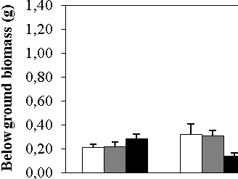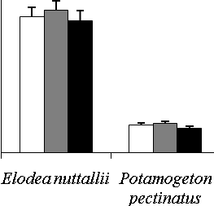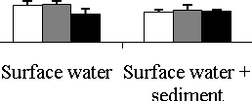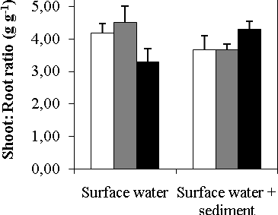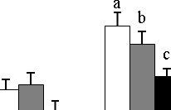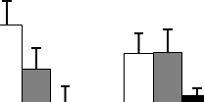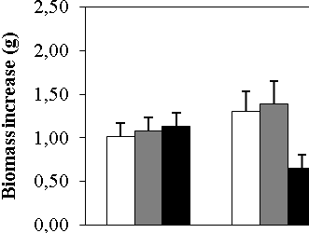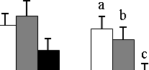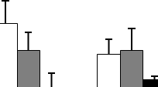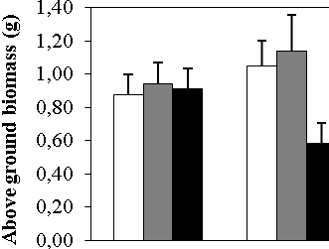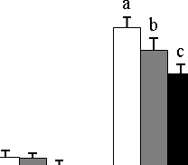
Place of addition combined
Elodea nuttallii
Potamogeton pectinatus
(b)
(a)
(g)
(l)
(k)
(j)
(i)
(h)
(f)
(e)
(d)
(c)

Figure 1 Below ground biomass (a,b,c), above ground biomass (d,e,f), total biomass increase (g,h,i) and shoot:root ratio (j,k,l) (average ± sem) in reaction to iron addition in the surface water and in surface water + sediment after 12 weeks for (a,d,g,j) Elodea nuttallii (b,e,h,k) Potamogeton pectinatus and (c,f,i,l) for place of addition combined for each macrophyte. White, grey and black bars represent respectively additions of 0, 25 and 50 g Fe m⁻². Significant differences between treatments are indicated by different letters (Analysis of variance, Tukey test, P ≤ 0.05).

(a)
(c)
(b)
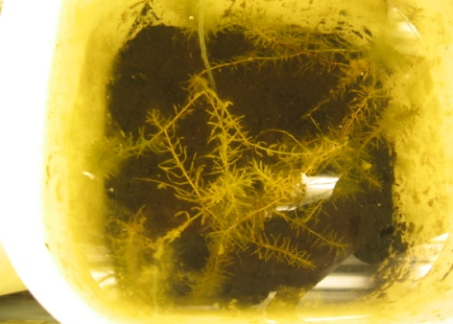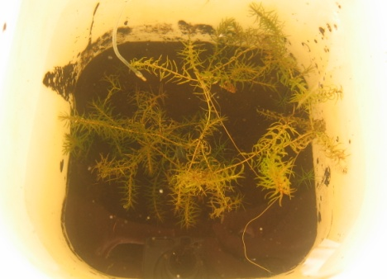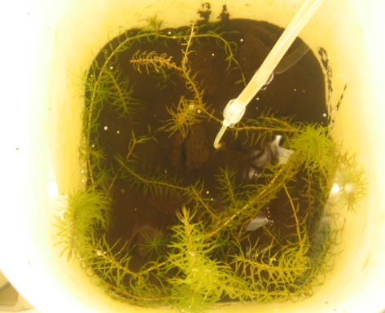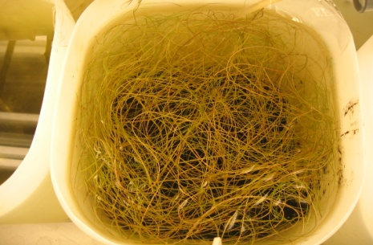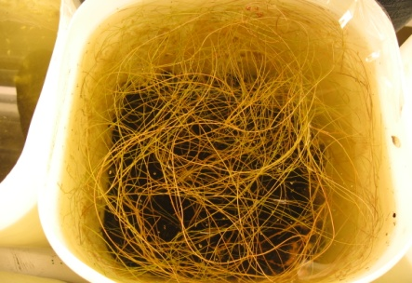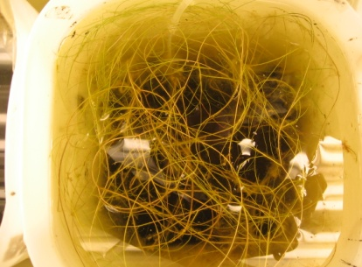
(f)
(e)
(d)

Figure 2 Pictures taken at 09-04-2010 of surface water addition tanks containing (a,b,c) E. nuttallii and (d,e,f) P. pectinatus receiving respectively 0, 25 and 50 g Fe m⁻².

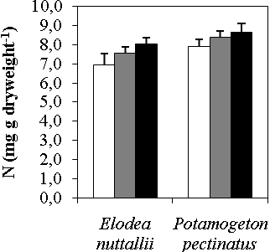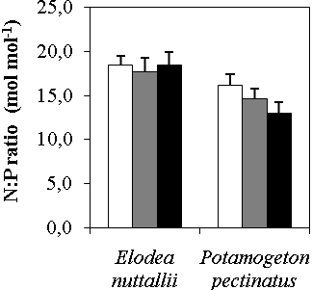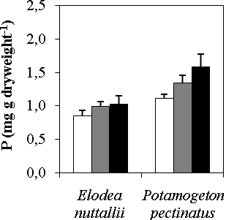
(c)
(b)
(a)

Figure 3 Aboveground macrophyte (a) N concentration (b) P concentration and (c) N:P ratio (average ± sem) in reaction to different iron treatments. White, grey and black bars represent respectively additions of 0, 25 and 50 g Fe m⁻². Significant differences between iron treatments are indicated by different letters (Analysis of variance, Tukey test, P ≤ 0.05).

Table 1 Results of analysis of the effects of iron addition on biomass, growth, shoot-root ratio and nutrient composition of Elodea nuttallii and Potamogeton pectinatus. Data were analysed with a two-way ANOVA with the amount of iron (0, 25 or 50 g m⁻²) and the place of addition (in water or sediment plus water) as fixed factors, n=5. Bold values indicate P ≤ 0.05
Effect | Iron amount  Df=2,24  (F, P) | Place  Df=1,24  (F, P) | Iron * Place  Df=2,24  (F, P)
Elodea nuttallii
Biomass below ground | 0.81, 0.46 | 0.21, 0.65 | 4.55, 0.02
Biomass above ground | 2.11, 0.14 | 0.01, 0.91 | 2.05, 0.15
Total biomass | 1.83, 0.18 | 0.04, 0.84 | 2.74, 0.08
Total biomass increase | 1.79, 0.19 | 0.06, 0.81 | 2.82, 0.08
Shoot-root ratio | 0.34, 0.72 | 0.18, 0.67 | 3.72, 0.04
N aboveground | 1.50, 0.24 | 0.01, 0.95 | 1.69, 0.21
N belowground | 3.62, 0.04 | 0.03, 0.87 | 1.12, 0.34
P aboveground | 0.95, 0.40 | 0.06, 0.80 | 0.54, 0.59
P belowground | 0.17, 0.84 | 0.28, 0.60 | 0.01, 0.99
N:P ratio aboveground | 0.09, 0.91 | 0.00, 0.98 | 0.85, 0.44
N:P ratio belowground | 2.32, 0.12 | 0.17, 0.69 | 0.06, 0.95
Potamogeton pectinatus
Biomass below ground | 4.55, 0.02 | 0.24, 0.63 | 0.63, 0.54
Biomass above ground | 3.60, 0.04 | 0.16, 0.70 | 0.66, 0.53
Total biomass | 4.74, 0.02 | 0.01, 0.92 | 0.65, 0.53
Total biomass increase | 4.91, 0.02 | 0.01, 0.93 | 0.71, 0.50
Shoot-root ratio | 1.00, 0.38 | 1.00, 0.33 | 0.95, 0.40
N aboveground | 0.80, 0.46 | 0.07, 0.80 | 1.65, 0.21
N belowground | 0.35, 0.71 | 2.34, 0.14 | 0.68, 0.52
P aboveground | 3.21, 0.06 | 0.88, 0.36 | 0.53, 0.60
P belowground | 1.12, 0.34 | 0.91, 0.35 | 1.10, 0.35
N:P ratio aboveground | 1.79, 0.19 | 0.14, 0.71 | 1.11, 0.35
N:P ratio belowground | 0.40, 0.68 | 0.21, 0.66 | 0.35, 0.71

Table 2 Results of analysis of the effects of iron addition on surface and pore water nutrient composition. Data were analysed with a two-way ANOVA with the amount of iron (0, 25 or 50 g m⁻²), the place of addition (in water or sediment plus water) and the macrophyte species (Elodea nuttallii, Potamogeton pectinatus or empty control treatments) as fixed factors, n=5. Bold values indicate P ≤ 0.05
Effect | Iron amount  Df=2,72  (F/H, P) | Place  Df=1,72  (F/H, P) | Plant  Df=2,72  (F/H, P) | Iron * Place  Df=2,72  (F/H, P) | Iron * Plant  Df=4,72  (F/H, P) | Place * Plant  Df=2,72  (F/H, P) | Iron * Place * Plant  Df=4,72  (F/H, P)
Surface water
Fe* | 28.46, <0.001 | 5.07, 0.02 | 2.30, 0.32 | 40.62, <0.001 | 35.70, <0.001 | 7.65, 0.18 | 57.57, <0.001
Fe (precipitated) | 17.04, <0.001 | 10.17, <0.001 | 0.34, 0.71 | 0.41, 0.67 | 1.36, 0.26 | 0.24, 0.79 | 1.60, 0.19
PO₄* | 1.01, 0.60 | 2.02, 0.16 | 1.01, 0.60 | 4.05, 0.54 | 7.08, 0.53 | 4.05, 0.54 | 16.18, 0.51
Cl | 185.18, <0.001 | 22.50, <0.001 | 0.39, 0.68 | 54.26, <0.001 | 0.43, 0.79 | 0.81, 0.45 | 0.81, 0.52
Al | 68.63, <0.001 | 1.87, 0.18 | 4.02, 0.02 | 3.44, 0.04 | 1.01, 0.41 | 0.71, 0.50 | 0.94, 0.45
Ca | 23.55, <0.001 | 1.30, 0.26 | 14.71, <0.001 | 2.01, 0.14 | 0.95, 0.44 | 0.01, 0.99 | 0.31, 0.87
SO₄ | 10.50, <0.001 | 0.14, 0.71 | 3.26, 0.04 | 3.33, 0.04 | 0.91, 0.46 | 0.51, 0.60 | 0.64, 0.63
NH₄* | 1.16, 0.56 | 0.18, 0.67 | 1.31, 0.52 | 4.57, 0.47 | 3.03, 0.93 | 2.26, 0.81 | 7.70, 0.97
NO₂ | 0.56, 0.57 | 7.70, 0.01 | 1.47, 0.24 | 2.19, 0.12 | 0.85, 0.50 | 0.43, 0.65 | 1.98, 0.11
NO₃* | 0.70, 0.70 | 0.24, 0.62 | 0.87, 0.39 | 1.32, 0.93 | 5.05, 0.75 | 4.72, 0.45 | 9.24, 0.93
pH | 66.30, <0.001 | 3.53, 0.06 | 22.06, <0.001 | 1.38, 0.26 | 1.35, 0.26 | 0.71, 0.50 | 0.39, 0.81
Alkalinity | 16.59, <0.001 | 10.45, 0.00 | 32.20, <0.001 | 1.38, 0.26 | 1.10, 0.37 | 1.02, 0.37 | 0.48, 0.75
Pore water
Fe | 1.42, 0.25 | 0.36, 0.55 | 5.90, <0.001 | 0.46, 0.53 | 0.24, 0.91 | 0.57, 0.57 | 0.68, 0.61
PO₄* | 0.19, 0.91 | 0.00, 0.95 | 7.29, 0.02 | 1.97, 0.85 | 11.87, 0.12 | 11.45, 0.04 | 20.60, 0.24
Fe:PO₄ ratio (10 weeks) | 0.95, 0.39 | 0.31, 0.58 | 9.18, <0.001 | 0.37, 0.69 | 0.44, 0.78 | 0.05, 0.96 | 0.74, 0.57
Cl | 147.38, <0.001 | 12.44, <0.001 | 0.17, 0.84 | 35.07, <0.001 | 0.21, 0.93 | 0.93, 0.40 | 0.74, 0.57
Al* | 36.19, <0.001 | 0.00, 0.97 | 5.11, 0.08 | 37.82, <0.001 | 42.25, <0.001 | 5.32, 0.38 | 45.24, <0.001
Ca | 21.55, <0.001 | 1.24, 0.27 | 3.98, 0.02 | 2.31, 0.11 | 0.42, 0.79 | 0.05, 0.95 | 0.70, 0.59
SO₄ | 4.48, 0.02 | 0.00, 1.00 | 4.25, 0.02 | 1.66, 0.20 | 0.44, 0.78 | 0.95, 0.39 | 0.47, 0.76
NH₄* | 2.98, 0.23 | 0.10, 0.75 | 0.05, 0.98 | 3.94, 0.56 | 13.79, 0.09 | 0.84, 0.97 | 16.64, 0.48
NO₂ | 0.03, 0.97 | 0.00, 0.98 | 0.38, 0.69 | 1.38, 0.26 | 0.71, 0.59 | 1.44, 0.25 | 0.66, 0.62
NO₃* | 5.26, 0.07 | 1.19, 0.27 | 0.80, 0.67 | 7.20, 0.21 | 9.55, 0.30 | 8.13, 0.15 | 18.99, 0.33
pH | 13.27, <0.001 | 0.42, 0.52 | 14.34, <0.001 | 2.57, 0.08 | 1.01, 0.41 | 0.07, 0.93 | 1.07, 0.38
Alkalinity | 5.29, 0.01 | 1.44, 0.23 | 5.59, 0.01 | 1.56, 0.22 | 0.97, 0.43 | 0.16, 0.85 | 0.66, 0.62
* Non-parametric Kruskall-Wallis test (H) performed instead of ANOVA (F)

