

**[7/1/2010]**

Rene van der Zande

Masha vander Sande

University Utrecht, Faculty of Betasciences, Department of Biology

Supervisor:

Anne Immers

NIOO

A research on the growth rate and nutrient composition of two macrophyte species and on the algae abundance

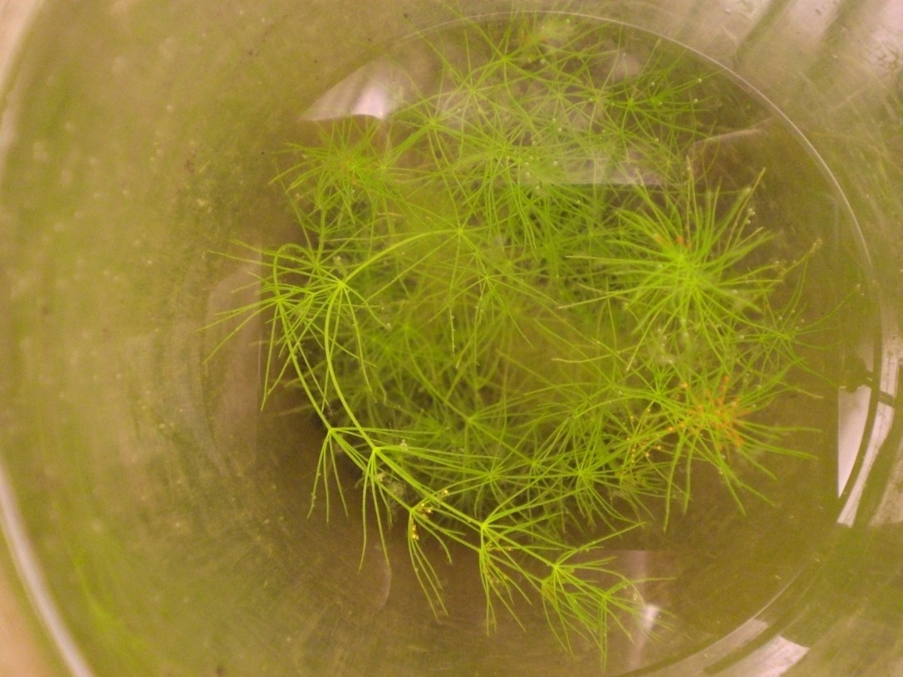

http://www.cradletocradle.nl/content/Image/news/2008/04/20080414_nioo.jpg**Introduction**

The effect of iron addition on macrophytes

Since 1950, excess nutrient (especially PO4) input from agricultural and wastewater runoff have caused eutrophication in European lakes. This can cause a phase shift, in which the underwater macrophyte (water plants) dominated vegetation is replaced by an algae dominated vegetation and the water becomes turbid (Brönmark & Hansson, 2005; Smolders *et al.*, 2001; lecture B. Ibelings, 2010). Especially in agriculture, large amounts of nutrients were added to the soil, which then contaminated aquatic systems and sharply increased their nutrient concentrations.

In order to restore and maintain these aquatic systems in their original state, the EU Water Framework Directive has been set up in 2000. This framework requires all European freshwater systems to be restored, or be in restoration, with original vegetation by 2015 (Gulati *et al.*, 2008).

If the nutrient concentration of an aquatic system keeps increasing, there can be an abrupt phase shift from a clear state dominated by macrophytes to a turbid state dominated by algae, the alternative steady state (Scheffer *et al.*, 2001). This phase shift results in the loss of species diversity (Geurts *et al.* 2008), especially macrophytes, as these plants fail to gain enough light for photosynthesis. Additionally, the loss of water plants can result in even more turbid water as the roots prevent sediment resuspension.

Several methods have been proposed in an attempt to restore turbid, algae dominated aquatic systems into their original clear, macrophyte dominated state. Dredging the lake is one of the oldest approaches to remove nutrient rich sediment (Annadotter *et al.*, 1999; Van der Does *et al.*, 1992). However, it is costly and difficult (Smolders *et al.*, 2001; Quaak *et al.*, 1993) Also, water-level regulation can improve water quality when more fluctuations in water-level are stimulated (Gulati *et al.*, 2008). In some cases, bad water quality was caused by resuspension of the sediment by wind or grazing animals, resulting in a turbid lake with no macrophyte growth. The first cause can be counteracted by creating small islands in the lake that reduce the effect of wind on resuspension (Gulati *et al.*, 2008). The re-suspension caused by herbivores (mainly fish) was attacked by biomanipulation. In this approach, animals that spade the sediment in order to find food are removed (Haterd & Heerdt, 2007). Biomanipulation can also be applied to reduce grazing pressure on the macrophytes, but proved to be only a short-term solution as grazers returned quickly (Haterd & Heerdt, 2007). Interference in the food web structure to increase grazing pressure on algae also proved futile (REF). Gulati *et al.* (2008) argued that better insight in food web structure and interrelationships is needed for a long-term effect. Moreover, it is proposed that the failure of biomanipulation is due to high PO4 concentrations, and the inability to control allochthonous and autochthonous PO4 fluxes (Geurts *et al.*, 2010).

According to Geurts *et al.* (2008), high concentrations of PO4 in the water are the cause of turbidity and macrophyte absence. High concentrations of PO4 are often caused by runoff of nutrient rich water. Even when this incoming flow of PO4 ceased the water often remained turbid, partly because much PO4 has accumulated in the sediment and is slowly re-dissolving in the water (Smolders *et al.*, 2001).

Normally, the runoff of PO4 rich water is counteracted by the iron rich groundwater flow (Geurts *et al.*, 2010). This iron is capable of binding PO4 and immobilizing it in the sediment. Therefore, another cause of the high PO4 concentrations is the iron rich groundwater flow interference (REF). (Quaak *et al.*, 1993; Smolders *et al.*, 2001). Smolders *et al.*, (2007) showed that ferric or ferrous chloride (FeCl2 or FeCl3) effectively binds with PO4, and hence decreases PO4 concentrations. The addition of iron salts therefore seems a good solution to reduce PO4 concentrations and re-establish macrophyte stands, since earlier biomanipulation experiments by Haterd & Heerdt, (2007) were successful. However, sulphur can counteract this immobilization of PO4 by binding with iron and thus mobilizing PO4 (van der Welle *et al.*, 2008).

The addition of iron can, however, be harmful as well. High concentrations of iron can be toxic to aquatic systems and so reduce the macrophyte growth (van der Welle *et al.*, 2005). Also, the time in which the FeCl3 is added can be important. The addition of FeCl3 that is spread out over a longer time period has found to be more effective. Also, the injection of FeCl3 into the sediment improved the results (Geurts *et al.*, 2010; Van der Welle *et al.*, 2005).

This study focuses on lake Terra Nova, a shallow peaty lake of 85 ha near Loenen, The Netherlands, which was formed as a result of peat extraction. About 60 years ago, more than 50% of the lake sediment was covered with macrophytes (Haterd & Heerdt, 2007). Despite the ceased runoff of nutrient rich water, the PO4 concentration of the lake remained high and the lake was dominated by algae. In order to restore the macrophyte rich lake, biomanipulation was carried out by Haterd & Heerdt (2007). However, the fish returned and the lake became turbid again. In order to reduce the concentration of PO4, and so favour macrophyte over algae growth, the addition of ferric chloride was proposed.

Due to positive results from previous studies, the Dutch Waterboard Waternet, which implements policies regarding lake Terra Nova, already started the addition of ferric chloride in lake Terra Nova. In order to confirm whether this approach will not harm other organisms in the food web, Immers and Mels-Vendrig tested the effect of ferric chloride addition on macrophytes. During this experiment they treated two different macrophyte species, *Elodea* *nuttallii* (waterweeds) and *Potamogeton pectinatus* (fennel pondweed) with 0, 20 and 40 g Fe m-2. The first results of this experiment indicate a decline in biomass of fennel pondweed with increasing iron concentrations. However, algal biomass declined as well with higher iron concentrations and the water remained clear.

However, the effect of this treatment is only known for the common species waterweeds and fennel pondweed. In order to investigate this effect on less common species, with a higher biodiversity value than waterweeds, a research is carried out with the species *Chara* *virgata* and *Chara globularis*. Here, the effect of three different ferric chloride concentrations (0, 20 and 40 g Fe m-2) on the growth and nutrient composition of both species, and on the growth of blue-green algae is investigated.

Decreasing PO4 concentrations for increasing FeCl3 addition treatments are expected. The lowest concentrations of PO4 also likely contain the lowest concentrations of blue-green algae. The addition of 20 g Fe m-2 will result in a competitive advantage of *C. virgata* and *C. globularis* compared to algae, while the addition of 40 g Fe m-2 is expected to be toxic. Therefore, the highest macrophyte growth is expected at a Fe concentration of 20 g m-2.

**Materials & Methods**

­­­­­­­­­­­­­­­­­­­­­­

**Experimental setup**

In order to test our hypotheses, a total of 45, 4L Plexiglas cylinders were filled with 0.5L Terra Nova sediment and 3.25L Terra Nova water. Average light intensity above the cylinders was 305 μE m-2 s-1 and average temperature was 21°C. The cylinders were kept at a 12-12 hour day-night cycle.

Nine different treatments, based on three different iron additions and two macrophyte species, were assigned to the 45 cylinders. All treatments were carried out in replicates of 5. Table 1 shows the treatment numbers with corresponding species, iron addition and cylinder numbers. In the remainder of this report these numbers will be used to indicate the relevant treatment.

***Table 1.*** Shortcut numbers for the 9 different macrophyte treatments used during the experiment. For each treatment, corresponding macrophyte species, iron addition and cylinder numbers are given.

|  |  |  |  |
| --- | --- | --- | --- |
| **Treatment number** | **Macrophyte species** | **Iron addition (g Fe m-2)** | **Cylinder numbers** |
| **1** | *Chara virgata* | 0 | 1, 2, 3, 4, 5 |
| **2** | *Chara virgata* | 20 | 6, 7, 8, 9, 10 |
| **3** | *Chara virgata* | 40 | 11, 12, 13, 14, 15 |
| **4** | *Chara globularis* | 0 | 16, 17, 18, 19, 20 |
| **5** | *Chara globularis* | 20 | 21, 22, 23, 24, 25 |
| **6** | *Chara globularis* | 40 | 26, 27, 28, 29, 30 |
| **7** | Control | 0 | 31, 32, 33, 34, 35 |
| **8** | Control | 20 | 36, 37, 38, 39, 40 |
| **9** | Control | 40 | 41, 42, 43, 44, 45 |

Three weighed individuals of *C. globularis* or *C. virgata* were planted in all cylinders containing macrophytes.

Three different FeCl3 treatments were used during the experiment: 0 g Fe m-2 (control), 20 g Fe m-2 and 40 g Fe m-2 (Table 1). Assuming an average lake Terra Nova depth of 1.4m, this corresponds with the addition of 0, 14.3 and 28.6 mg FeCl3 L-1 respectively. Of the 15 cylinders per macrophyte species (including the control with no macrophytes), 5 cylinders received the 0 g FeCl3 m-2 treatment, 5 cylinders the 20 and 5 cylinders the 40 g Fe m-2 treatment. This iron was added in equal proportions over the 9 days that the measurements were carried out. In the cylinders without FeCl3 addition, an equal amount of chloride ions in the form of NaCl were added to compensate for possible effects of the Cl- ions on the experiment.

All cylinders were randomly assigned in a climate chamber to ensure constant environmental factors. Evaporated water was replaced with filtered Terra Nova water.

**Measurements**

*Before the experiment*

For both *Chara* species the above- and belowground fresh biomass for several plants was measured. The samples were then dried and corresponding dry mass measured. The wet:dry biomass ratio was calculated and used to estimate dry biomass of the plant cuttings planted in the cylinders. The C:N and P ratio of the sample plants was also measured by ing. Nico Helmsing. From 15 randomly selected cylinders a water sample was collected, filtered over a Whatman GF/C filter (1.2 μm, Ø 24 mm), frozen, and later delivered to ing. Nico Helmsing for nutrient (NH4+, NO3-, NO2- and PO4) composition analysis. From the same cylinders a water sample was analyzed with a PhytoPAM phytoplankton analyzer and PhytoWIN US software for chlorophyll content, composition and photosynthetic activity. Samples were then treated with 1% glutaraldehyde and the PhytoPAM analysis was performed again. The gain was kept at 21.

*Weekly*

The experiment continued for 5 weeks. There were 2 measuring days in every week, except for the last week in which there was 1 measuring day. The following measurements were taken weekly on the same day. Chlorophyll content and composition, as well as photosynthetic activity of the algae in the cylinders was measured using a PhytoPAM phytoplankton analyzer and PhytoWIN US software. Next, samples were treated with 1% glutaraldehyde and analyzed again. The gain was kept on 19 during PhytoPAM measurements, but was adjusted for chlorophyll values too high for this gain. Water samples of each cylinder were collected, frozen, and delivered to ing. Nico Helmsing for nutrient (NH4+, NO3-, NO2- and PO4) analysis. Alkalinity and pH were measured in each cylinder using a standard pH meter and conductivity with a standard conductivity meter. Of each cylinder photographs were taken from above.

The following measurements were carried out twice a week. The percentage of ground area covered by macrophytes and algae was estimated, as well as the amount of zooplankton (see Table 2) in all cylinders. Newly germinated *Chara* species were counted and removed from the control cylinders (without macrophytes).

***Table 2:*** Classification scale for the amount of Zooplankton.

|  |  |
| --- | --- |
| **Scale** | **Number of individuals** |
| **1** | 0 |
| **2** | 1 |
| **3** | 2-3 |
| **4** | 4-5 |
| **5** | 6-10 |
| **6** | 11-15 |
| **7** | 16-25 |
| **8** | 26-50 |
| **9** | 51-100 |
| **10** | >100 |

*After the experiment*

All macrophytes from the cylinders were harvested, divided in above- and belowground biomass and dried. The dry mass was weighed and C:N and P ratios were calculated by ing. Nico Helmsing.

**Results**

**Growth**

*Ground area coverage*

The increase in ground area coverage by *C. virgata* (Figure 1a) and *C. globularis* (Figure 1b) is shown in Figure 1. The measurement points for both species are linearly correlated (r2>0.9). For *C. virgata* an increase from 0-4% at the initiation of the experiment to 16-26% at the end of the experiment was found. The ground area coverage for *C. globularis* was found to increase from 39-51% to 75-87% between the initiation and final situation (see also Table 1).

No difference was found in the rate at which the ground area coverage increased among the different treatments for both macrophyte species (trendline angle) and among the final ground area coverage for all treatments.

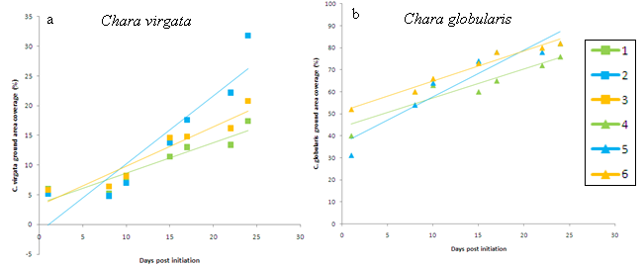

***Figure 1:***Ground area coverage increase in percentages for *C. virgata* (a) and *C. globularis* (b). The green line represents the 0 g Fe m-2 treatment, the blue line the 20 g Fe m-2 treatment and the orange line the 40 g Fe m-2 treatment. Squares and triangles represent *C. virgata* and *C. globularis* respectively.

*Aboveground dry biomass*

No aboveground growth difference was found among treatment 1, 2 and 3, while the growth of treatment 4 was found to be higher than 5 and 6 (p=0.000), and the growth of treatment 5 to be higher than 6 (p=0.002) (Figure 2).

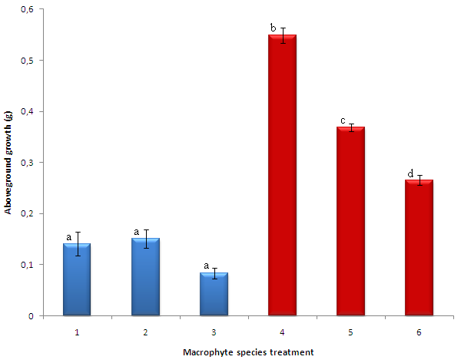

***Figure 2:*** Aboveground biomass increase in grams during the experiment for treatments 1 to 6. *C. globularis* had a higher biomass increase than *C.* virgata. Differences in growth were found among treatments 4, 5 and 6.

**Macrophyte nutrient composition**

*N:P ratio*

From the results a trend was visible of increasing N:P ratios during the experiment for all treatments except treatment 1 (Figure 3). For *C. virgata*, treatment 3 had a higher N:P ratio than the initial N:P ratio (p=0.044). There was no difference in N:P ratio found among treatments 1, 2 and 3. For *C. globularis* treatments 5 (p=0.002) and 6 (p=0.011) were found to have higher N:P ratio than the initial N:P ratio. The N:P ratio of treatment 4 was found to be lower than treatment 5. There was no difference in N:P ratio between treatments 4 and 6 and between treatments 5 and 6.

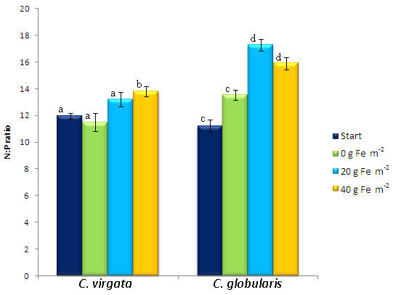

***Figure 3:*** N:P ratios for the initial situation (dark blue bar) and for all treatments at the final situation. Green bars represent 0 g Fe m-2 treatments, light blue the 20 g Fe m-2 and orange the 40 g Fe m-2 treatments for both *C. virgata* and *C. globularis*. Differences between initial and final N:P ratios were found for treatment 3, 5 and 6.

*N Concentrations*

Figure 4 shows a trend that for both *C. virgata* and *C. globularis* the final N concentrations in the plant are higher than the initial N concentrations in the plant. Treatments 1 (p=0.004), 2, 3 (both p=0.000) , 5 and 6 (both p=0.001) were found to have higher N concentrations compared to their initial N concentrations. There was no difference found between the initial and final N concentrations of treatment 4.

For the final N concentrations, treatment 4 was found to be different from treatment 5 (p=0.017) and 6 (p=0.003). No difference in N concentrations among treatments 1, 2 and 3 were found.

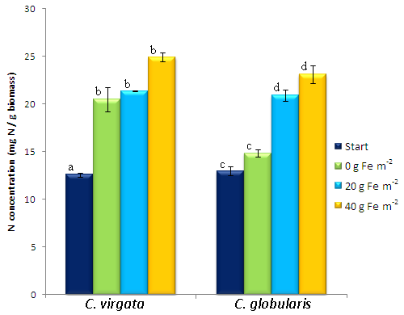

***Figure 4:*** N concentrations for the initial situation (dark blue bar) and for all treatments at the final situation. Green bars represent 0 g Fe m-2 treatments, light blue the 20 g Fe m-2 and orange the 40 g Fe m-2 treatments for both *C. virgata* and *C. globularis* differences between initial and final N concentrations were found for treatment 1, 2, 3, 5 and 6.

*P concentrations*

All *C. virgata* treatments had an increased P concentrations compared to the initial P concentrations (p=0.000) (Figure 5). For *C. globularis*, no difference in P concentrations were found between the final and initial P concentrations of treatment 5. Treatment 4 (p=0.022) and 6 (p=0.000) were found to have a respectively lower and higher P concentration than the initial P concentration.

The P concentrations of treatments 4, 5 and 6 were found to differ from each other (p=0.015, p=0.000, p=0.000 respectively). Among the P concentrations of treatments 1, 2 and 3 no difference was found.

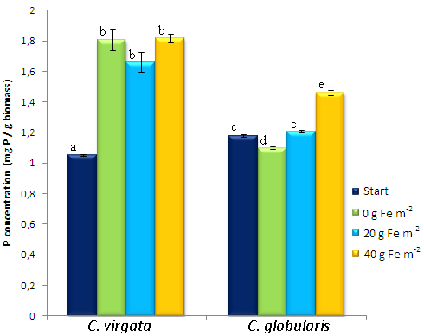

***Figure 5:*** P concentrations for the initial situation (dark blue bar) and for all treatments at the final situation. Green bars represent 0 g Fe m-2 treatments, light blue the 20 g Fe m-2 and orange the 40 g Fe m-2 treatments for both *C. virgata* and *C. globularis*.Differences between initial and final P concentrations were found for treatment 1, 2, 3, 4 and 6.

**Water nutrient composition**

All treatments started off with the same nutrient composition. Figure 6 shows the changes in phosphate (PO4) and Figure 7 the changes in nitrate (NO3) for the different treatments during the experiment.

*PO4*

All treatments were found to have higher PO4 concentrations than the initial PO4 concentration (p<0.05). In most samples the PO4 concentrations initially decreased, followed by an increase (Figure 6a). No difference was found among treatments 4, 5 and 6, and among treatments 7, 8 and 9. Treatment 1 was found to be higher than treatment 2 (p=0.042) and 3 (p=0.045).

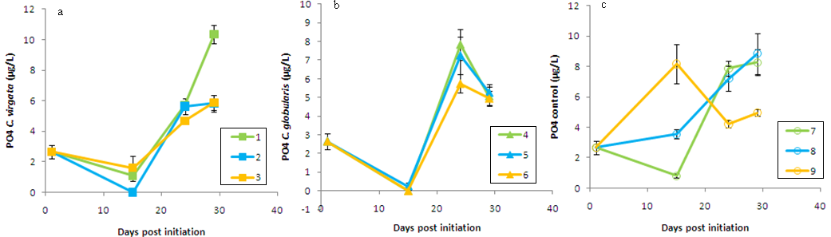***Figure 6:*** Water Phosphate (PO4) concentrations. Water PO4 concentrations are shown for *C. virgata* (a), *C. globularis* (b) and control (c) treatments. Green lines represent 0 g Fe m-2 treatments, blue lines 20 g Fe m-2 treatments, and orange lines 40 g Fe m-2 treatments. Squares, triangles and open circles represent *C. virgata, C. globularis* and control treatments respectively. PO4 concentrations of all treatments are higher than the initial PO4 concentrations.

*NO3*

There was no trend visible in the NO3 concentrations for the different treatments during the experiment (Figure 6c). Treatments 2, 3, 4, 5, 6, 8 and 9 had lower NO3 concentrations compared to the initial NO3 concentration (p<0.05). Treatment 1 was found to have a higher NO3 concentration after natural logarithmic transformation than treatment 2 (p=0.042) and 3 (p=0.001).

Treatment 1 was found to be higher than treatment 2 and 3. There was no difference in NO3 concentrations found among treatments 4, 5 and 6, and among treatments 7, 8 and 9.

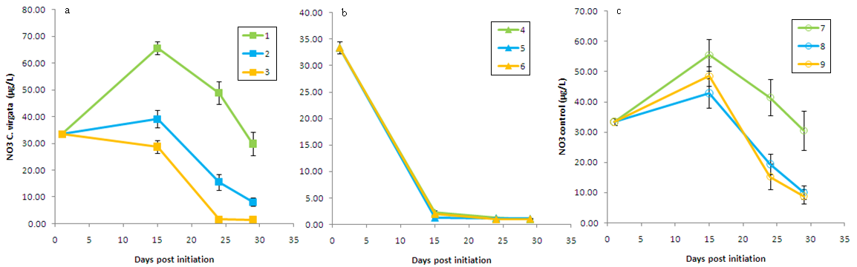

***Figure 7:*** Water (NO3) nitrate concentrations. NO3 concentrations are shown for *C. virgata* (a), *C. globularis* (b) and control (c) treatments. The green lines represent the 0 g Fe m-2 treatment, blue lines the 20 g Fe m-2 treatment and orange lines the 40 g Fe m-2 treatment. Squares, triangles and open circles represent *C. virgata*, *C. globularis* and control treatments respectively. Treatments 2, 3, 4, 5, 6, 8 and 9 have lower NO3 concentrations than the initial NO3 concentration. Treatments 1 and 7 show no difference in NO3 concentrations compared with the initial NO3 concentration.

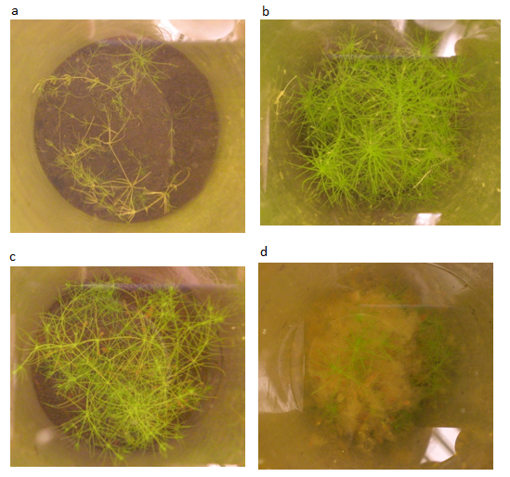

***Figure 8:*** Different photographs of *Chara* species at the final situation. (a) shows *C. virgata* for treatment 1, (b) shows *C. globularis* for treatment 4, (c) shows *C. virgata* for treatment 2, and (d) shows *C. globularis* for treatment 6.

**Blue-green algae**

During the experiment, an overall decline in blue-green algae was measured (Appendix 1). Overall, it was seen that blue algae grew best without microphytes, second best with *C. virgata*, and worst with *C.* *globularis*. At day 24, highest chlorophyll concentrations were measured in the treatments with 40 g Fe m-2, but corresponding yield was found to be zero. Highest yield was found in the control treatments (7, 8 and 9), low yield in the treatments with *C.* *virgata* and no yield in the treatments with *C. globularis.* At day 29, only yield was found for treatment 1. All the other treatments (2 to 9) had a yield of zero.

**Discussion**

This research focused on the reaction of two different macrophyte species, *Chara* *virgata* and *Chara* *globularis*, on three different iron ion concentrations. The growth and nutrient composition of both species were measured, as well as the blue-green algae growth. The question was how both species differed for these aspects under different iron addition concentrations. In order to discuss the results, first the growth and nutrient composition of *C. virgata* will be evaluated, second the growth and nutrient compostition of *C. globularis*, third the nutrient composition of the water of all treatments (including the treatments without macrophytes), and finally the presence of blue-green algae in all treatments will be discussed.

***Chara virgata***

*Macrophyte growth*

As can be seen from Figure 1a and 2, there was no growth difference and no difference in coverage area found among the treatments of *C. virgata*. This indicates that the addition of iron does not affect the growth rate and growth allocation of this species. However, a trend could be seen with the highest increase of growth in the samples receiving 20 g Fe m-2 (Figure 2). This corresponds to previous studies (Immers & Mels-Vendrig, 2010) and to the hypothesis. From Figures 1b it can be seen that *C. virgata* grew slowly during the first 10 to 15 days. This can be explained by the fact that *C. virgata* had no roots when it was planted, and so needed longer time to fully establish. When the experiment had lasted longer, probably a greater difference in growth could be seen among the three treatments.

*Macrophyte nutrient composition*

Only treatment 3 showed an increase of the N:P ratio during the experiment (Figure 3). This means that the in the final situation the macrophytes contained more N compared to P, which may point at a relative limitation of P due to the addition of FeCl3, or to an enhancement of N uptake. However, because addition of Fe in theory immobilizes PO4, it is reasonable that this could be the reason for the increased N:P values. This supports the hypothesis that the addition of FeCl3 causes PO4 in the water, and subsequently the P in the macrophytes to decline, and so causes an increase of N:P ratio.

The N concentration in the macrophytes increased for all treatments during the experiment (Figure 4). However, no differences were found among the 0, 20 and 40 g Fe m-2 treatments, which indicates that iron does not affect the N uptake.

The same was observed for the P concentrations (Figure 5). The increase in P concentrations indicate that P was not limiting, as could be expected from the increased N:P ratios. There was no difference found among the final P concentrations of the three treatments, which implies that iron addition did not affect the relative uptake of P. This contradicts the hypothesis. When iron was added, a decrease of PO4 in the water was expected, which would be expected to result in a limitation of P. An increase in N:P ratio suggests that P is limited. However, since the concentration of P in the plant had increased, it is probably not limiting. This can be explained by the fact that *C.* *virgata* had no roots in the beginning of the experiment. They were planted in the sediment and developed roots during the experiment with which P could be taken up from the soil. This increased the possibilities of C. *virgata* to take up P since P is not limited in the soil, and therefore the final P concentrations were higher. Another possibility is that there was in fact no PO4 limitation of the plants at all. Similar experiments using different macrophyte species all used much higher concentrations of FeCl3. Geurts *et al.,* (2010), Van Der Welle *et al.,* (2008) and Smolders *et al.,* (1995) added up to 100 g Fe m-2, while in this experiment maximally 40 g Fe m-2 was added. Therefore it could well be that clear effects of PO4 immobilization by Fe binding have not taken place during the experiment. Moreover, it is argued that iron addition by adding it to the surface water is not as effective as injecting it directly into the sediment (Geurts *et al.,* 2010), what could explain why no signs of P limitation were found during the experiment.

***Chara globularis***

*Macrophyte growth*

Among the treatments of *C. globularis* no differences in coverage area were found (Figure 1b). However, growth of treatment 4 was found to be higher than 5 and 6, and 5 to be higher than 6 (Figure 2). This indicates that the addition of FeCl3 negatively influences macrophyte growth. Iron toxicity cannot explain this trend, since iron concentrations have not reached a level that is toxic to macrophytes (Van der Welle *et al.,* 2005). However, as can be seen in Figure 8, the FeCl3 heavily precipitated on the macrophyte leaves. This possibly caused light limitation and therefore a decrease of photosynthesis and growth.

*Macrophyte nutrient composition*

An increase of the N:P ratio was found between initial and final situations for treatment 5 and 6 (Figure 3). This indicates that, as was also the case for *C. virgata*, P was relatively more limited in the final compared to the initial situations. The final N:P ratio of treatment 4 was found to be lower than 5. These results support the hypothesis that iron addition causes a relative limitation of P compared to N.

Treatments 5 and 6 increased in N concentrations during the experiment (Figure 4). This points, contrary to *C. virgata*, to an increase of N uptake due to the addition of iron since there was no increase in N concentration in treatment 4. However, since growth declined with increased iron addition, the same concentration of N was available for a smaller biomass of macrophytes in the treatments where FeCl3 was added. This may indicate that treatments 5 and 6 increased their N concentrations because relatively more N was available.

The overall P concentration increased less than in *C. virgata* (Figure 5). This can be explained by the fact that *C. globularis* already had roots from the beginning, so no extra possibility of capturing P was developed during the experiment. However, the P concentration of treatment 4 decreased during the experiment, while that of treatment 6 increased. This indicates that iron positively influences the uptake of P. This is counterintuitive, since iron was expected to decrease the PO4 concentration in the water and therefore lower the uptake of P or PO4 by macrophytes. However, because the growth decreased with increased addition of FeCl3, an increasing relative P was available for the macrophytes in treatment 4, 5 and 6 respectively. This can explain the increased P concentration in macrophytes receiving the highest concentration of iron.

**Water nutrient composition of all treatments**

*PO4*

For all *C. virgata* treatments, the PO4 concentration was found to increase during the experiments (Figure 6a). However, treatment 1 increased more than 2 and 3. This indicates that iron indeed lowers the concentration of PO4 in the water, but that more PO4 dissolves at the sediment-water interface than is bound to iron, and so PO4 concentrations net increase. However, no difference was found between treatment 2 and 3, which indicates that the addition of more iron did not result in a further decline of PO4.

Although a trend was visible of decreasing PO4 concentrations for treatments 4, 5 and 6 respectively, no significant differences were found (Figure 6b). This violates the hypothesis that iron would decrease PO4 concentrations. When looking at the iron addition concentrations, treatment 6 should have the lowest PO4 concentration in the water. However, decrease of growth for treatments 4, 5 and 6 respectively result in most PO4 taken up in treatment 4 and least in treatment 6. The high PO4 concentrations in treatment 4 due to no addition of iron were compensated by higher uptake of PO4 for growth. This results in equal PO4 concentrations in the water for all treatments. Probably the increasing macrophyte P concentrations in treatment 4, 5 and 6 respectively do not fully compensate for the absolute increase in growth. In this way, it is explained that treatments 4, 5 and 6 contain the same PO4 concentrations.

The PO4 concentrations of all control treatments were found to increase during the experiment, and no differences among the treatments were found (Figure 6c). This supports the explanation that more PO4 dissolves at the sediment-water interface than can be bound to iron. However, no differences were found among the treatments. This violates the explanation that PO4 is taken up by macrophytes and therefore the PO4 concentration is not lower in the treatments where iron was added. Apparently the PO4 concentrations are not much affected by the presence of macrophytes. Therefore, there should be an alternative explanation for the fact that PO4 does not decreases with increasing FeCl3 addition.

These findings contradict the findings by Quaak *et al.* (1993), Smolders *et al.* (2001)and Geurts *et al.* (2010). One explanation of the difference in results is that too little iron was added. The addition of iron did not cause a net decrease of PO4 in the water. Therefore, the effect of iron is possibly not strong enough to see clear results. Also, PO4 was seen to highly fluctuate over the time. When iron was added over a longer time period, a better result is expected since fluctuation will decrease and differences in growth will increase. Also the injection of iron into the sediment would yield better results (Geurts *et al.*, 2010).

*NO3*

For *C. virgata* and the control treatments an increase of NO3 followed by a decrease of NO3 was found (Figure 7a). This could be explained by a reaction of NO2 into NO3. Treatment 1 contained higher NO3 concentrations compared to treatments 2 and 3. This implies that iron decreases the NO3 concentration in the water. NO3 is also taken up by macrophytes. But since the growth did not differ among the treatments, the differences in NO3 concentrations cannot be explained by differences in uptake. Therefore, iron addition should have another effect on NO3, which is not yet clear.

The NO3 concentrations for all *C. globularis* treatments showed a fast decline immediately from the initiation of the experiment (Figure 7b). This can be explained by the uptake of NO3 for macrophyte growth. Because *C. globularis* already contained roots from the beginning of the experiment, no time was needed to fully establish, and so growth was seen directly from the initiation (see also Figure 1b).This fast growth explains the decline NO3 that is needed for growth. No differences were found among the three treatments, so iron did not seem to affect NO3 concentrations.

For the control treatments a difference was found between treatment 7 and treatments 8 and 9 combined (Figure 7c). This implies, as was also the case for *C. virgata*, that iron addition decreases NO3. Since macrophyte growth cannot influence this concentration, there should be some other effect of iron on NO3.

Taken together, the effect of iron on NO3 is not fully clear. This can also be explained by the addition of too little iron to obtain clear results. Although iron seems to affect NO3 concentrations, more factors are important that influence NO3. Therefore, further research is needed with increased iron addition concentrations so that more clear results can be obtained. Only in this way, it can be concluded if, and how, iron affects NO3.

**Blue-green algae**

During the experiment, the algae abundance declined (Appendix 1). At the end, highest concentrations of blue-green algae were found in treatments without macrophytes. This indicates that macrophytes compete with algae, and that the presence of macrophytes decreased the amount of algae. Overall, *C.* *virgata* contained more algae than *C.* *globularis*, which may point at a difference in competitive strength. This is also supported by the fact that in the final situation, only treatment 1 was found to contain blue-green algae of the macrophyte treatments. It is possible that *C.* *globularis* takes up so much nitrate, that there is not enough left in the water for the algae to grow (Figure 7b).

However, no clear differences were found among the different iron addition treatments. This indicates that iron does not affect the presence of algae. There is a distinct state of nutrient concentrations at which the system shifts to an alternative steady-state dominated by algae. Because algae were not abundant in the initial situation, their abundance remained low when iron was added. When aiming for a shift from an algae dominated to a macrophyte dominated lake, nutrient compositions have to be decreased more than the distinct point of nutrient concentrations that caused the shift towards an algae dominated lake (Scheffer *et al*, 2001). In order to test whether iron addition leads to a shift to a macrophyte dominated lake, the algae should be present in high abundances from the initiation of the experiment. Also, algae concentrations fluctuated a lot during the experiment. Probably more time is needed to clearly see a trend of increasing or decreasing algae abundance.

**Conclusion**

It was in vestigated how the addition of iron affected two macrophyte species for their growth rate and nutrient composition, and how the abundance of blue-green algae changed.

It was shown that the addition of iron did not affect the growth of *C. virgata*, but decreased the growth of *C. globularis*. However, this decrease was probably caused by light limitation due to iron precipitation on the macrophyte’s leaves, rather than by PO4 limitation that would lead to a relative advantage compared to algae. The fact that iron did not affect macrophyte growth in this way was explained by the addition of too low iron concentrations over too short time periods. The PO4 concentrations in the sediment were so high that the absolute PO4 concentrations increased during the experiment. The addition of more iron divided over a longer time period, together with the injection of iron into the sediment, would obtain better results. The injection into the sediment would reduce the iron precipitation on leaves and more effectively bind the PO4 that dissolves at the sediment-water interface. In this case, PO4 concentrations in the water will decline and P will become more limited. In this way, also the changes in NO3 can probably be better explained.

The difference between the two species is mainly explained by a different initial situation. Fast growth of *C. globularis* was caused by the presence of roots already from the initiation of the experiment. *C. virgata*, however, contained no roots and therefore showed slow growth rates at the first 10 to 15 days of the experiment. The development of roots resulted in an extra way to take up nutrients, which was reflected by the increase of macrophyte P and N concentrations that were higher than *C. globularis*.

Blue-green algae abundance was low for all treatments, especially for treatments containing macrophytes. This indicates that there indeed is competition. However, blue-green algae did not dominate at the initiation of the experiment, and so no effect of iron addition on the turning point from a algae dominated to a macrophyte dominated state. Therefore, it could not be tested whether the addition of iron would lead to a macrophyte dominated lake.

Taken together, the overall conclusion of this experiment is that iron addition can effectively reduce nutrient availability in freshwater systems, provided that it is added in sufficient amount and directly into the sediment where it is readily used to bind PO4, and does not precipitate on the macrophyte leaves. In this way it is very likely that nutrient concentrations, and particularly P, decline, and therefore a competitive advantage for macrophytes compared to algae is created.

**References:**

Smolders, A.J.P., Laamers, L.P.M., Moonen, M., Zwaga, K. & Roelofs, J.G.M. 2001. Controlling phosphate release from phosphate-enriched sediments by adding various iron compounds. Biochemistry **54**, pp. 219-228.

Van de Haterd, R.J.W & ter Heerdt, G.N.J. 2007. Potential for the development of submerched macrophytes in eutrophicated shallow peaty lakes after restoration measures. Hydrobiologia **584**, pp. 277-290.

Geurts, J.J.M., Smolders, A.J.P., Verhoeven, J.T.A., Roelofs, J.G.M. & Lamers, L.P.M. 2008. Sediment Fe:PO4 ratio as diagnostic and prognostic tool for the restoration of macrophyte biodiversity in fen waters. Freshwater Biology **53**, pp. 2101-2116.

Gulati, R.D., Miguel Dionisio Pires, L. & Van Donk, E. 2008. Lake restoration studies: failures, bottlenecks and prospects of new ecotechnological measures. Lymnologica **38**, pp. 233-247.

Van der Welle, M.E.W., Cuppens, M., Lamers, L.P.M. & Roelofs, J.G.M. 2006. Detoxifying taxicants: interactions between sulphide and iron toxicity in freshwater wetlands. Environmental Toxicology and Chemistry **25**, 6, pp. 1593-1597.

Quaak, M., Van der Does, J., Broers, P. & Van der Vlugt, J. 1993. A new technique to reduce internal phosphorous loading by in-lake phosphate fixation in shallow lakes. Hydrobiologia **253**, pp. 337-344.

Scheffer, M., Carpenter, S., Foley, J.A., Folke, C. & Walker, B. 2001. Catastrophic shifts in ecosystems. Nature **413**, pp.

Geurts, J.J.M., Smolders, A.J.P., Roelofs, J.G.M. & Lamers, L.P.M. 2010. Restoration of fens and peat lakes: a biogeochemical approach, Chapter 5: Iron addition to surface water or sediment as a measure to restore water quality in organic soft-water lakes. In press.

***Appendix 1:*** FytoPAM measurments. Cholorfyl and Yield for blue-green algae are measured on 14, 24 and 29 days post initiation.

|  |  |  |  |  |  |  |
| --- | --- | --- | --- | --- | --- | --- |
|  | Days post initiation | |  |  |  |  |
|  | 14 |  | 24 |  | 29 |  |
| Treatment | Chloforyl | Yield | Chloforyl | Yield | Chloforyl | Yield |
| 1 | 0,13 | 0,78 | 0 | 0 | 0,02 | 0,52 |
| 1 | 0,11 | 0 | 0 | 0 | 0,04 | 0,52 |
| 1 | 0,1 | 0 | 0,38 | 0 | 0,08 | 0,71 |
| 1 | 0,06 | 0,38 | 0,03 | 0 | 0,03 | 0,75 |
| 1 | 0,05 | 0,33 | 0,09 | 0 | 0,03 | 0,53 |
| 2 | 0,04 | 0,37 | 0 | 0 | 0 | 0 |
| 2 | 0,04 | 0 | 0 | 0 | 0 | 0 |
| 2 | 0,14 | 0,41 | 0,15 | 0,41 | 0 | 0 |
| 2 | 0,11 | 0,43 | 0,15 | 0,66 | 0 | 0 |
| 2 | 0,04 | 0,35 | 0,24 | 0 | 0 | 0 |
| 3 | 0,22 | 0,55 | 0,49 | 0 | 0,24 | 0,9 |
| 3 | 0,13 | 0,63 | 0,48 | 0 | 0 | 0 |
| 3 | 0,5 | 0,48 | 1,06 | 0 | 0 | 0 |
| 3 | 0,28 | 0 | 0,26 | 0 | 0 | 0 |
| 3 | 0,28 | 0,12 | 0 | 0 | 0 | 0 |
| 4 | 0,12 | 0 | 0,14 | 0 | 0 | 0 |
| 4 | 0,1 | 0 | 0,16 | 0 | 0,04 | 0 |
| 4 | 0,08 | 0 | 0,03 | 0 | 0 | 0 |
| 4 | 0 | 0 | 0,04 | 0 | 0 | 0 |
| 4 | 0,08 | 0 | 0,04 | 0 | 0 | 0 |
| 5 | 0,06 | 0 | 0 | 0 | 0 | 0 |
| 5 | 0,08 | 0 | 0 | 0 | 0 | 0 |
| 5 | 0,05 | 0 | 0 | 0 | 0 | 0 |
| 5 | 0,03 | 0 | 0,08 | 0 | 0 | 0 |
| 5 | 0,05 | 0 | 0 | 0 | 0 | 0 |
| 6 | 0,02 | 0 | 0 | 0 | 0 | 0 |
| 6 | 0,03 | 0 | 0 | 0 | 0 | 0 |
| 6 | 0,09 | 0 | 0 | 0 | 0 | 0 |
| 6 | 0,09 | 0 | 0 | 0 | 0 | 0 |
| 6 | 0,03 | 0 | 0 | 0 | 0 | 0 |
| 7 | 0,14 | 0 | 0,17 | 0 | 0 | 0 |
| 7 | 0,19 | 0,93 | 0 | 0 | 0 | 0 |
| 7 | 0,07 | 0,48 | 0,06 | 0 | 0 | 0 |
| 7 | 0,06 | 0,33 | 0 | 0 | 0 | 0 |
| 7 | 0,1 | 0,3 | 0,03 | 0,56 | 0 | 0 |
| 8 | 0,27 | 0,76 | 0,2 | 0,64 | 0 | 0 |
| 8 | 0,04 | 0,57 | 0 | 0 | 0 | 0 |
| 8 | 0,05 | 0,55 | 0,14 | 0,47 | 0 | 0 |
| 8 | 0,65 | 0 | 0,18 | 0,67 | 0 | 0 |
| 8 | 0,06 | 0 | 0,2 | 0,68 | 0,4 | 0 |
| 9 | 0,13 | 0,62 | 0,96 | 0,73 | 0,13 | 0 |
| 9 | 0,27 | 0,64 | 0,33 | 0 | 0,14 | 0 |
| 9 | 0,11 | 0,6 | 0 | 0 | 0 | 0 |
| 9 | 0,1 | 0 | 0,23 | 0 | 0,38 | 0 |
| 9 | 0,14 | 0,61 | 0,43 | 0 | 0,18 | 0 |